PREVENTION OF FALLS IN THE GERIATRIC POPULATION
1. The elderly are prone to falling and therefore they need to be taken care of by their family members.
2. The elderly should always have a person around them to help them in case they need any assistance especially when ambulating.
3. Nutrition and exercise is an important part of the elderly life and this should be encouraged.
4. The elderly need medical attention promptly in case they get sick in order to avoid severe complications. This is due to the fact that elderly people have an incompetent immune system hence the need to prevent complications.

WHAT THE FAMILY/RELATIVE SHOULD KNOW

MEASURES TO PREVENT FALLS

1. Avoid slippery floor
2. Avoid walking in dark paths and rooms
3. Always have someone to assist you stand up when you cannot do it on your own
4. Avoid climbing the stairs
5. Always take a rest after taking medications known to cause dizziness

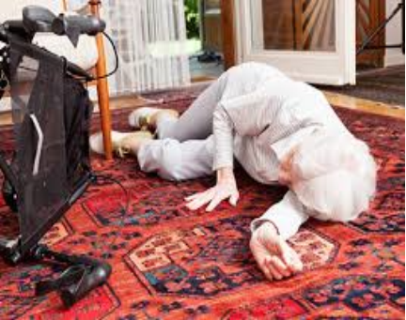
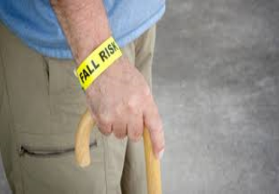

References
Gelbard, R., Inaba, K., Okoye, O. T., Morrell, M., Saadi, Z., Lam, L., ... & Demetriades, D. (2014). Falls in the elderly: a modern look at an old problem. The American Journal of Surgery, 208(2), 249-253.
Kwan, E., Straus, S., & Holroyd-Leduc, J. (2016). Risk Factors for Falls in the Elderly. In Medication-Related Falls in Older People (pp. 91-101). Adis, Cham.
Stenhagen, M., Ekström, H., Nordell, E., & Elmståhl, S. (2014). Accidental falls, health-related quality of life and life satisfaction: a prospective study of the general elderly population. Archives of gerontology and geriatrics, 58(1), 95-100.


LET US ALL JOIN HANDS TOGETHER AND TAKE CARE OF OUR ELDERLY AND PREVENT THIS POTENTIALLY FATAL OCCURRENCE….
LOCAL RESOURCES IN THE COMMUNITY THAT CAN ADDRESS THE PROBLEM…..
♦ Healthcare facilities
¨ Local community Based Organizations
¨ Non-governmental Organizations
¨ Community homes for the elderly

